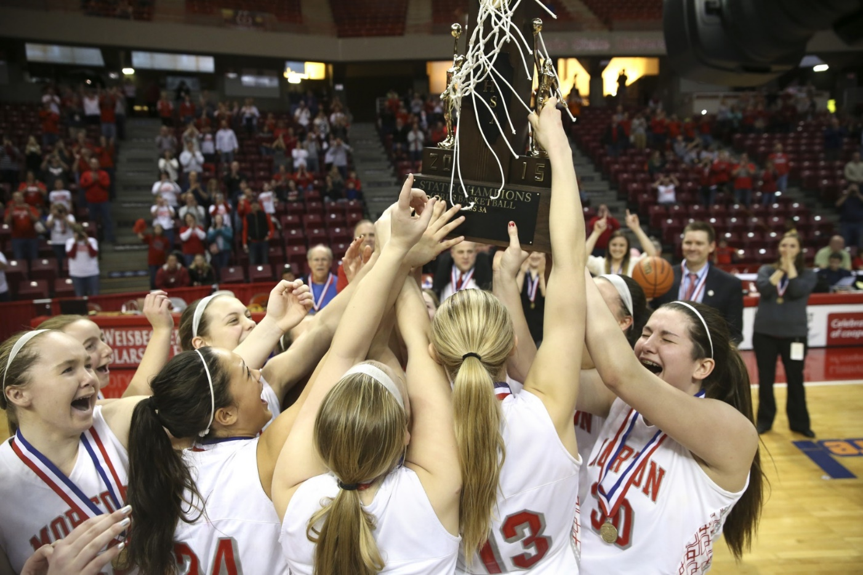
FUTURE CHAMPIONS
Morton Lady Potter
Summer Basketball Camps 2024

This is where the journey begins. All of our players were once summer campers like you. Join our players and coaches this summer to begin learning the Potter Way. You will learn fundamentals of basketball while meeting new friends and having FUN. All camps are instructed by Morton 709 coaches and players. Each camper will be treated with TLC (tender loving care) and it’s our hope for all campers to learn some basketball, meet new friends, and have fun while sparking a love for Lady Potter Basketball! We look forward to working with you!

Offensive Skills Camp May 29,30,31 Grades 3-8 8am-9:30am $60

This camp is all about offense! Ballhandling, passing, footwork, moves & finishes and shooting fundamentals will be emphasized. Campers will be instructed on shooting mechanics along with an array of individual offensive skills designed to help each player succeed on the offensive end of the court. All campers will receive a t-shirt. THREE-day camp runs Wednesday – Friday and will utilize the Junior High School Gyms. ALL CAMPERS please report to Junior High Gyms.

FUNdamental Camp 1 June 10th-13th Grades 6-8 8am-9:45am $75

Our FUNdamental Camp will consist of fun, action-packed FOUR days designed to develop each camper’s fundamental skills and overall playing ability. Fundamentals will be stressed but fun is main priority! Camp will include team-oriented situations as well as individual skill development and a variety of competitive camp games. We want camp to be an enjoyable Potter experience working with our players and coaching staff. This is a great way to meet other kids interested in basketball and learn a bit of our Potter Way. All campers will receive a t-shirt at each camp. Four-day camp runs Monday – Thursday and will utilize the High School Main Gym. Please enter through High School front door on Illinois Street and enter main gym.

Future Ballers Camp June 11-13th Grades K-2 8am-9:30am $60
This camp is designed for our youngest Lady Potters from grades K-2! This 3-Day Camp is designed for fun and a positive introduction to Potter basketball! Our players and staff cannot wait to share three fun-filled days together making new friends and learning some basketball. All campers will receive a ball and t-shirt to take home. 3-Day camp runs Tuesday-Thursday and will be held at LINCOLN GRADE SCHOOL GYM. Please enter doors on South end of LINCOLN SCHOOL and head into the gym!

FUNdamental Camp 2 June 17th-20th Grades 3-4 8am-9:30am LINCOLN SCHOOL $75
FUNdamental Camp 2 June 17th-20th Grades 5-6 8am-9:45am Morton High School $75

Our FUNdamental Camp 2 will consist of another fun, action-packed FOUR days designed to develop each camper’s fundamental skills and overall playing ability. Fundamentals will be stressed but fun is main priority! Camp will include team-oriented situations as well as individual skill development and a variety of competitive camp games. We want camp to be an enjoyable Potter experience working with our players and coaching staff. This is a great way to meet other kids interested in basketball and learn a bit of our Potter Way. All campers will receive a t-shirt. Four-day camp runs Monday – Thursday and will utilize the High School Main Gym (grades 5/6) as well as the Lincoln Elementary School Gym (grades 3/4). Grades 3 and 4 should report to Lincoln Elementary School. Grades 5 and 6 should report to the High School and enter through front door on Illinois Street.

Morton High School Potters Grades 9th -12th $200
May 29, 30, 31 9:45am-11:30am MORTON JUNIOR HIGH
May 28, June 3, 4, 5, 6, 10, 11, 12, 13, 17, 18, 19, 20, 24 (11:45am-1pm) Morton High School
June 3, 10, 17 8pm-9:30pm MORTON HIGH SCHOOL
These 17 dates are for Morton High School registered players and are designed to help build our championship players and team. Individual skill development along with introducing team concepts will be emphasized. All players planning to play during the summer and winter are strongly encouraged to participate. These count as some of our IHSA contact dates and will serve as summer practices. Summer fee of $200 covers it all which also includes league fees and varsity team camp!

Please direct all questions to Morton Head Coach Bob Becker
Email: Robert.becker@mcusd709.org Phone # 309-642-4432
Be sure to visit our Morton Lady Potter Basketball website! www.mortonladypotters.com
Morton Lady Potter Summer Basketball Camps 2024

Registration Form:
Camper Information:

Name_________________________________ Entering GRADE ______________________

T-shirt size circle Youth M Youth L Adult S Adult M Adult L Adult XL

Camper medical concerns? Please note any medical conditions or medications you want our staff to be aware of. __________________________________________________________________________________________________________________________________________________________

Parent/Guardian Information:
Contact Parent or Guardian Name _________________________Phone__________________

Secondary / Emergency Phone # (_____)________________________________

Please circle camp/s you are registering for. Please be sure to note dates/times and locations this summer for your particular campers grade level!! Thank you!!!!

Offensive Skills Camp Junior High Grades 3-8 May 29-31 8am-9:30am $60
Future Ballers Camp Lincoln School Grades K-2 June 11-13 8am-9:30am $60
FUNdamental Camp 1 High School Grades 6-8 June 10-13 8am-9:45am $75
FUNdamental Camp 2 Lincoln School Grades 3-4 June 17-20 8am-9:30am $75
FUNdamental Camp 2 High School Grades 5-6 June 17-20 8am-9:45am $75

Morton High School Potters Grades 9th -12th $200
SEE SUMMER SCHEDULE ABOVE OR REQUEST COPY FROM COACH.

$$ Payment Information $$
Checks are preferred and should be made payable to Morton High School Girls Basketball. Please seal in an envelope with camper’s first and last name included. If paying with cash, please seal exact amount in an envelope with camper’s first and last name.
Please turn in this form along with payment by May 17th at Morton High School main office.

Total Camp Fees: $__________

